**High Level Narrative Summary**

**Major Locations**

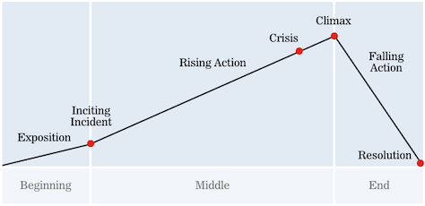

[Flash back]

* Tribe village – Exposition
  + Your character looks around and sees a small village nestled in the welcoming arms of a mountain range.
  + Smell of smoke and general chatter brings you back to your thoughts.
  + Your eyes scanning the forest that is just out of reach from where your temporary settlement lays; secluded and safe.
  + You decide to explore your home, wandering throughout the small area and come upon a place to trade, weapons, and huts of various shapes and sizes.
  + Able to speak to some of the villagers, however pain overcomes you and your vision warps slightly causing you to grip your head in confusion and pain.
  + You head back to your home where your mother awaits, greeting her, before laying down some furs and falling asleep.
* Inside hut – Inciting Incident
  + You wake up, the hut afire and puddled in blood. You scream, shouting for help. However, when the others arrive everything is fine, your mind was hallucinating.

[Continues after flashback]

* Around a camp fire.
  + Facing your mother, and the shaman, who says;
    - Your heart is haunted, and your mind is in a dark place. You are being exiled from your home but only until you defeat your demons.
    - You are handed a spear and a bow, as you walk out towards the forest. The sun setting as the forest darkens, its mouth stretching open in an ominous manner as the shadows consume you.
* Middle area.
  + Here you can choose one of three directions. Each direction leads you on a short journey to defeat a certain type of demon.
  + Each direction is equipped to a different element.
* Path 1 – Darkness/Loneliness
  + Puzzles.
  + Boss.
* Path 2 – Winter/Cold
  + Puzzles.
  + Boss.
* Path 3 – Fire/Evil
  + Puzzles.
  + Boss.
* Tribe village – Resolution.
  + Arrives back at the village in welcoming arms.
  + The sun glimmers in your eyes as it rises.
  + Fades to black.

**Characters**

Nzir –

* Your character.
* Young male.
* Naïve/scared.

Shaman –

* Elder male.
* Position of knowledge and all knowing.

Nzir’s mother –

* Middle-aged female.
* Loving/thoughtful/worried.

Villagers (Small interactions dialogue):

* Man making a speer tip.
* Woman cooking food.

Boss 1 –

* Darkness boss.

Boss 2 –

* Ice boss.

Boss 3 –

* Fire boss.